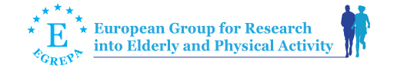

NAME: ___________________________________________________
INSTITUTION: ___________________________________________________
ADDRESS: ___________________________________________________
CITY/STATE/ZIP: ___________________________________________________
PHONE: ___________________________________________________
FAX: ___________________________________________________
E-MAIL: ___________________________________________________

DATE: ___________________________________________________

Please mark the option for your membership

One year membership (2022)
□ 40 Euro Individual □ 20 Euro Student □ 100 Euro Institution*

Two years membership (2022-2023)
□ 72 Euro Individual □ 180 Euro Institution*

* Individual members of a member institution pay 50% (20 Euro for one year or 36 Euro for two years membership)

Signature:

Please mail or fax this page to: EGREPA (student members please include evicence of student status)
e-mail: michael.brach@uni-muenster.de
fax: ++49 251 83-34862
phone: ++49 251 83-38420
__________________________________________________________________________________________
Pay the membership fee via paypal. Log into your paypal account and send money to EGREPA's email address: office@egrepa.org"

You can also make bank transfer payable to:

Payee: European Group for Research into Elderly and Physical Activity
Account: IBAN: DE42 4005 0150 0034 2208 06 (Account No: 34220806)
Bank name: Sparkasse Muensterland-Ost (Swift-BIC: WELADED1MST , BLZ: 40050150)
Bank address: Weseler Straße 230, 48151 Münster
Payment for: EGREPA membership 2022 or 2022 & 2023 (include YOUR NAME)

Thank you very much! Michael Brach, Treasurer

